# Create a key space with name students.

1. Create a column family with name student_info.
2. Insert the values into the table in batch.

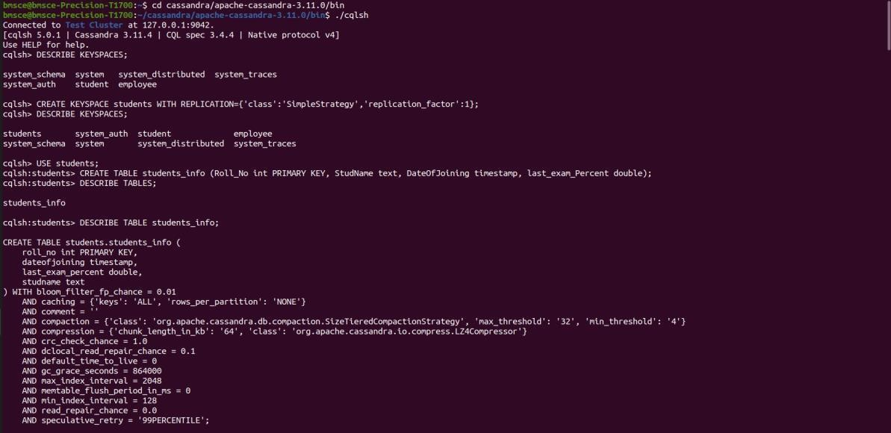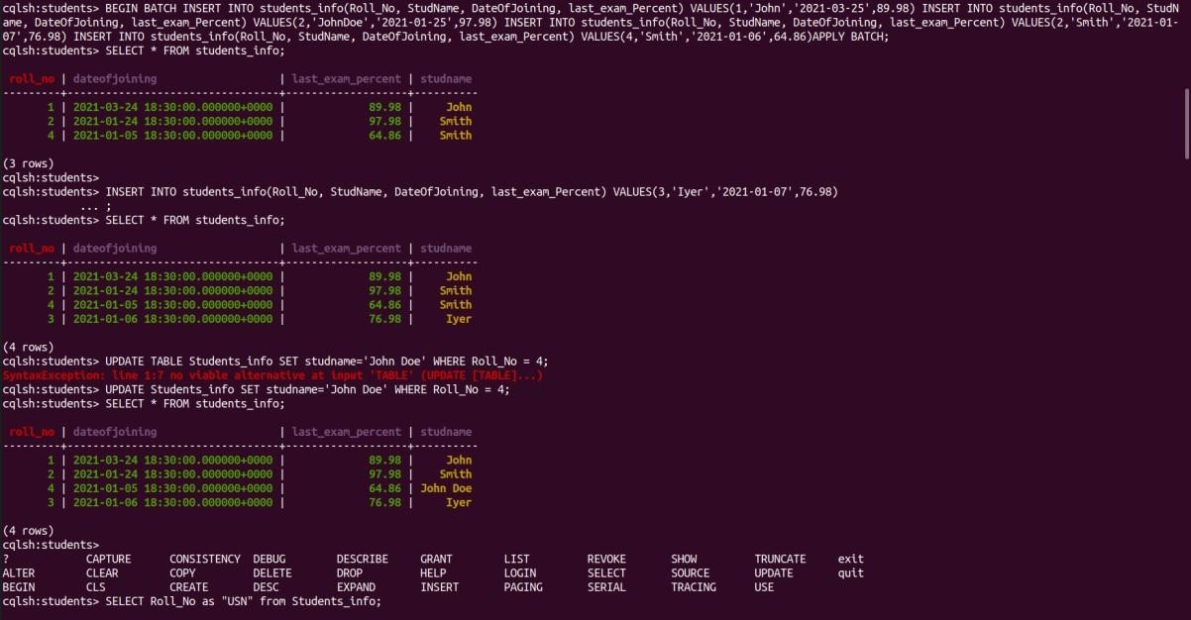

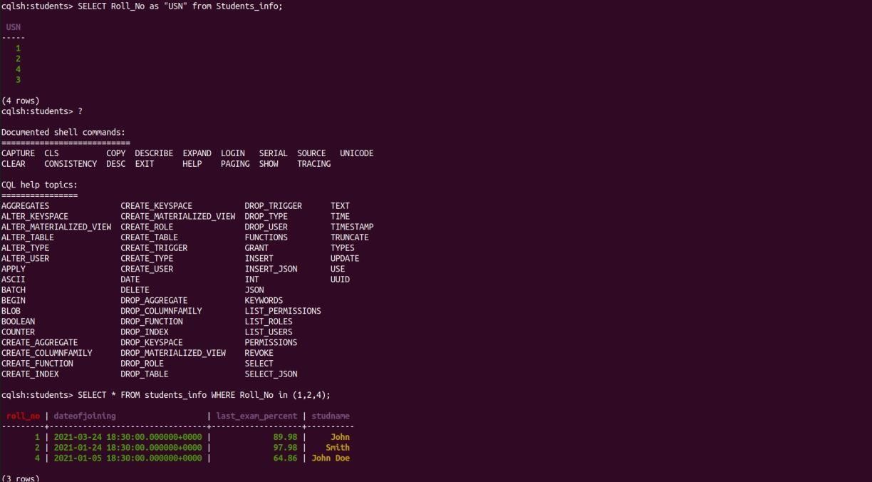

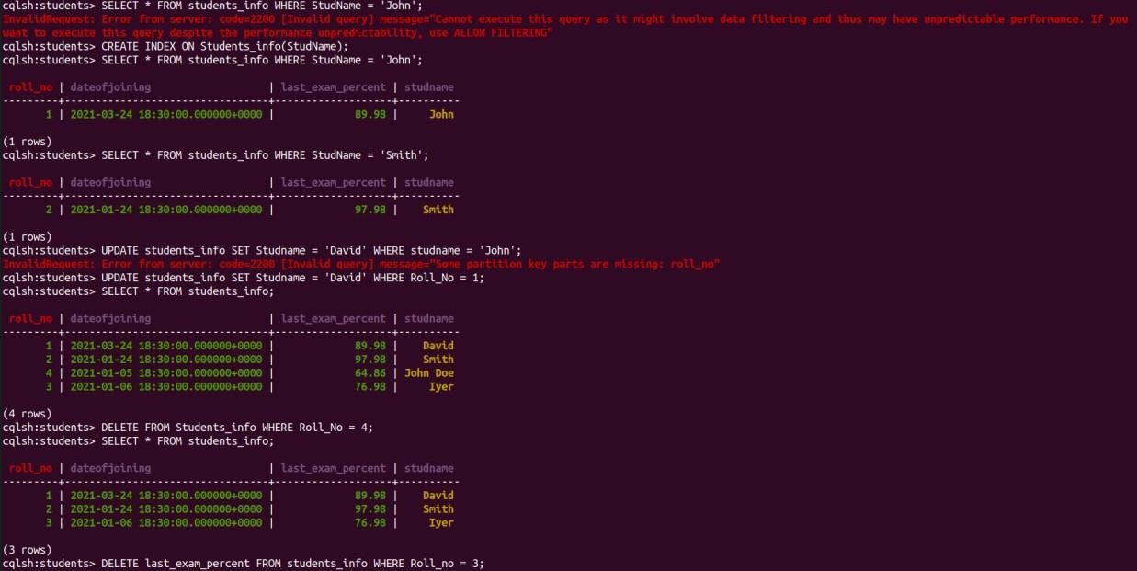

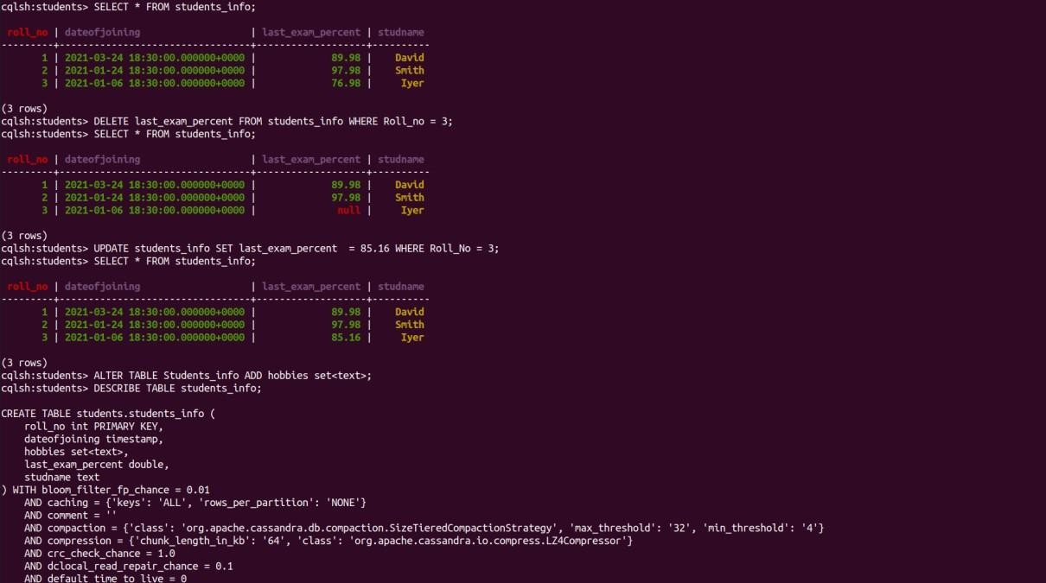

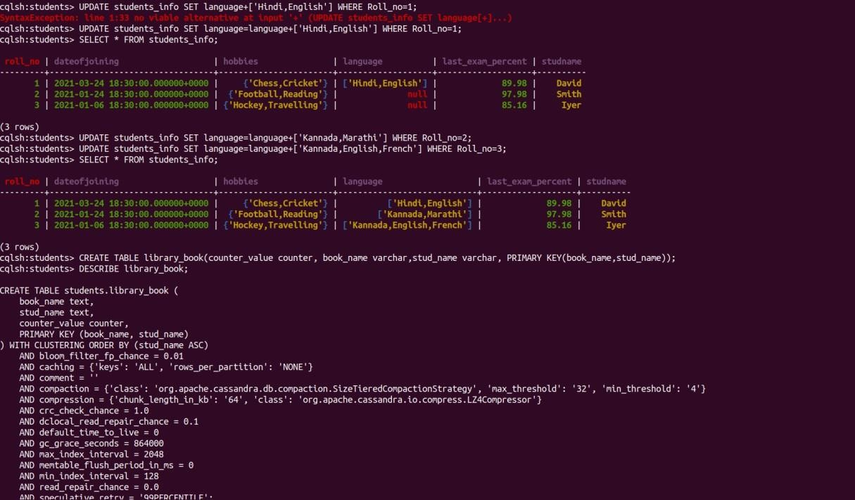

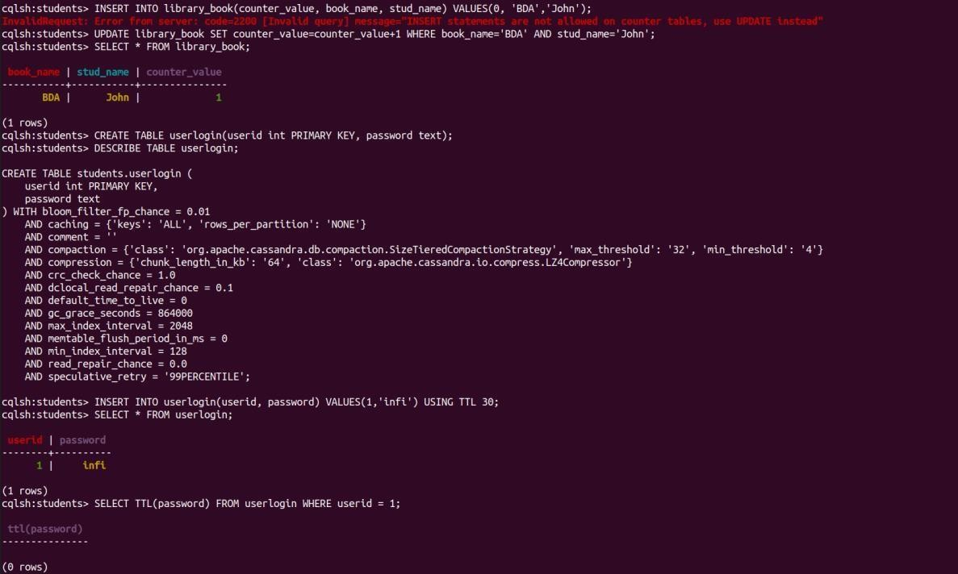

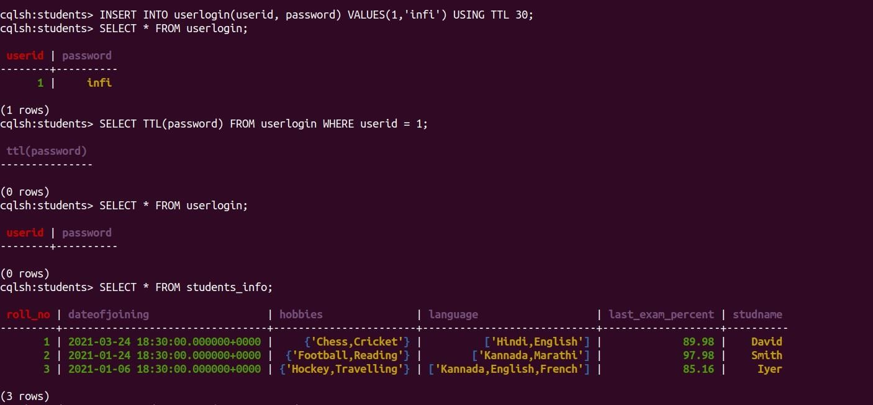

1. Perform the following DB operations using Cassandra.
   1. Create a keyspace by name Employee.
   2. Create a column family by name Employee-Info with attributes Emp_Id Primary Key, Emp_Name, Designation, Date_of_Joining, Salary, Dept_Name.
   3. Insert the values into the table in batch.
   4. Update Employee name and Department of Emp-Id 121
   5. Sort the details of Employee records based on salary
   6. Alter the schema of the table Employee_Info to add a column Projects which stores a set of Projects done by the corresponding Employee.
   7. Update the altered table to add project names.
   8. Create a TTL of 15 seconds to display the values of Employees.

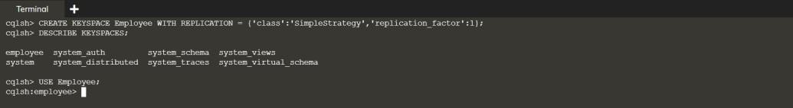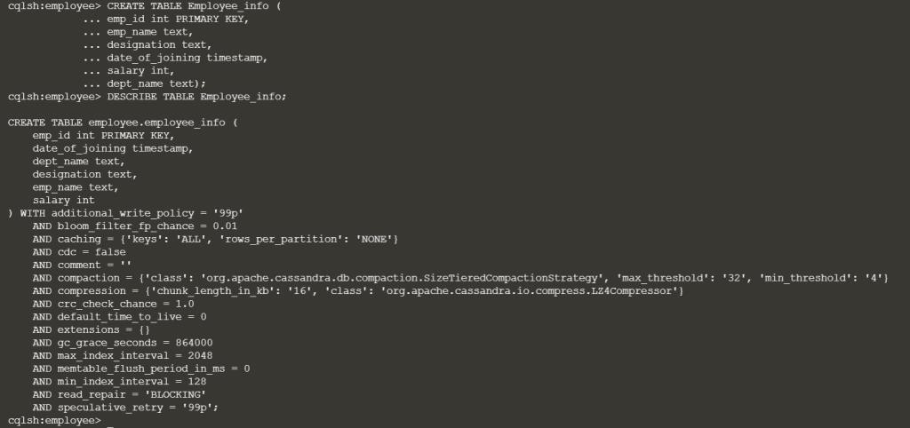

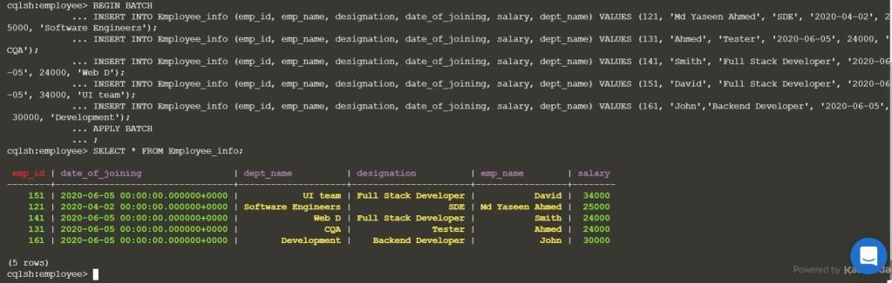

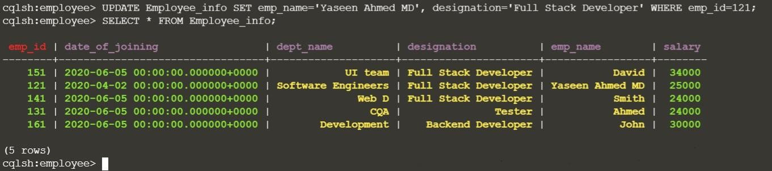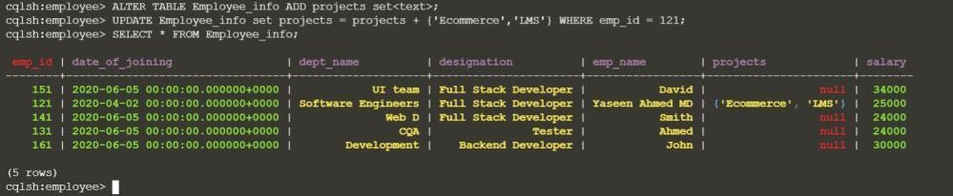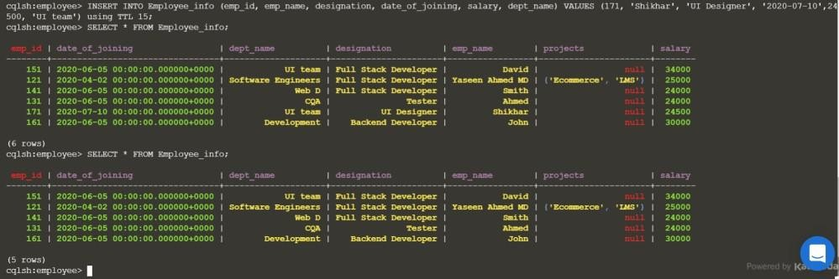

1. Perform the following DB operations using Cassandra.
   1. Create a keyspace by name Library.
   2. Create a column family by name Library-Info with attributes Stud_Id Primary Key, Counter_value of type Counter, Stud_Name, Book-Name, Book-Id, Date_of_issue.
   3. Insert the values into the table in batch.
   4. Display the details of the table created and increase the value of the counter.
   5. Write a query to show that a student with id 112 has taken a book

“BDA” 2 times.

* 1. Export the created column to a csv file.
  2. Import a given csv dataset from local file system into Cassandra column family

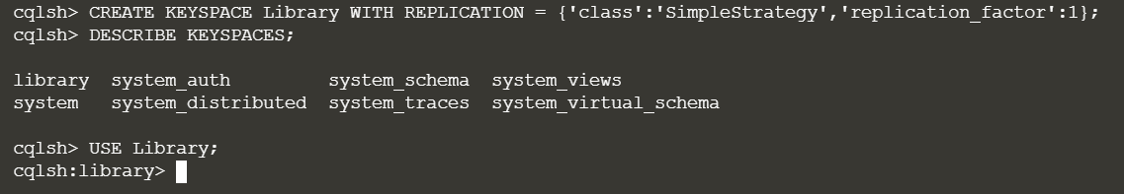

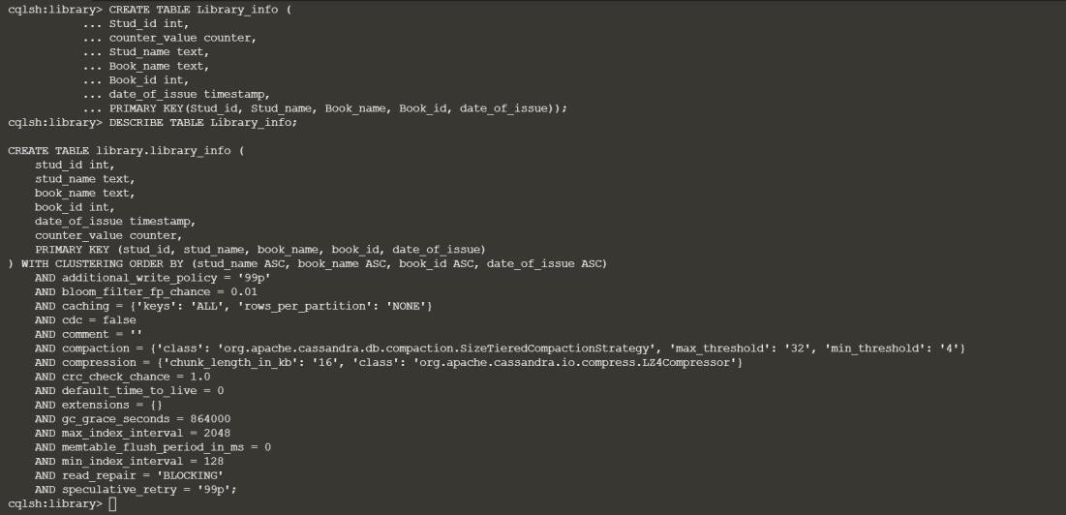

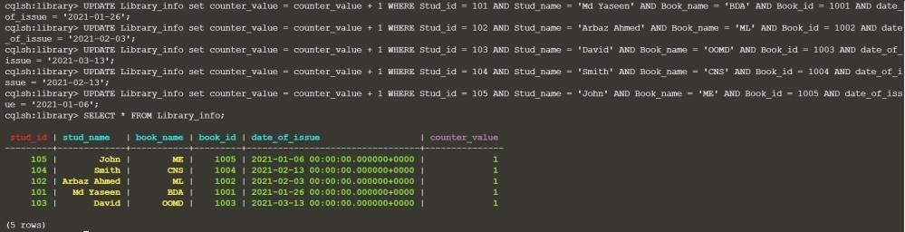

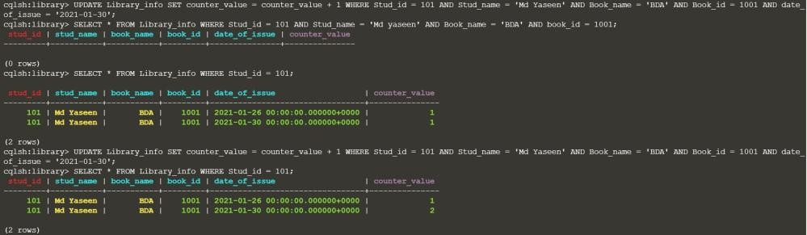

## Create a new collection

use Student

## Insert a value

db.Student.insert({ "Name" : "Akash",

"RollNo:" : 1,

"Age" : 21,

"ContactNo" : "7894561230",

"EmailId": ["akasha@gmail.com](mailto:akasha@gmail.com)"

})

## Insert multiple values at once

var MyStudents = [

{

"Name" : "Akshay",

"RollNo:" : 2,

"Age" : 22,

"ContactNo" : "8945612370",

"EmailId": ["akshay@gmail.com](mailto:akshay@gmail.com)"

},

{

"Name" : "Anand",

"RollNo:" : 3,

"Age" : 21,

"ContactNo" : "1234567890",

"EmailId" : "[anand@gmail.com](mailto:anand@gmail.com)"

},

{

"Name" : "Ayesha",

"RollNo:" : 4,

"Age" : 20,

"ContactNo" : "5289631470",

"EmailId" : "[ayesha@gmail.com](mailto:ayesha@gmail.com)"

},

{

"Name" : "Vinay",

"RollNo:" : 5,

"Age" : 18,

"ContactNo" : "4561237890",

"EmailId" : "[vinay@gmail.com](mailto:vinay@gmail.com)"

},

]

db.Student.insert(MyStudents);

## Print all current values

db.getCollection('Student').find({}).forEach(printjson)

{

"_id" : ObjectId("606ad5a6e581cc0b904470a5"), "Name" : "Akash",

"RollNo:" : 1,

"Age" : 21,

"ContactNo" : "7894561230",

"EmailId": ["akasha@gmail.com](mailto:akasha@gmail.com)"

}

{

"_id" : ObjectId("606ad60fe581cc0b904470a6"), "Name" : "Akshay",

"RollNo:" : 2,

"Age" : 22,

"ContactNo" : "8945612370",

"EmailId": ["akshay@gmail.com](mailto:akshay@gmail.com)"

}

{

"_id" : ObjectId("606ad60fe581cc0b904470a7"), "Name" : "Anand",

"RollNo:" : 3,

"Age" : 21,

"ContactNo" : "1234567890",

"EmailId" : "[anand@gmail.com](mailto:anand@gmail.com)"

}

{

"_id" : ObjectId("606ad60fe581cc0b904470a8"), "Name" : "Ayesha",

"RollNo:" : 4,

"Age" : 20,

"ContactNo" : "5289631470",

"EmailId" : "[ayesha@gmail.com](mailto:ayesha@gmail.com)"

{

"_id" : ObjectId("606ad60fe581cc0b904470a9"), "Name" : "Vinay",

"RollNo:" : 10,

"Age" : 18,

"ContactNo" : "4561237890",

"EmailId" : "[vinay@gmail.com](mailto:vinay@gmail.com)"

}

1. Update RollNo of a student db.Student.update(

{"RollNo:" : 10},

{$set: { "EmailId" : "[updated@gmail.com](mailto:updated@gmail.com)"}}); db.getCollection('Student').find({"RollNo:":10}).forEach(printjson)

{

"_id" : ObjectId("606ad60fe581cc0b904470a9"), "Name" : "Vinay",

"RollNo:" : 10,

"Age" : 18,

"ContactNo" : "4561237890",

"EmailId" : "[updated@gmail.com](mailto:updated@gmail.com)"

}

## Update Name of a student

db.Student.update(

{"Name" : "Akshay"},

{$set: { "Name" : "Avanthika"}});

db.getCollection('Student').find({"Name" : "Avanthika"}).forEach(printjson)

{

"_id" : ObjectId("606ad5a6e581cc0b904470a5"), "Name" : "Avanthika",

"RollNo:" : 2,

"Age" : 22,

"ContactNo" : "8945612370",

"EmailId": ["akshay@gmail.com](mailto:akshay@gmail.com)"

1. Export to json

mongoexport --db testdb --collection Student --out C:\Users\ Desktop\Student.json

{"_id" : ObjectId("606ad5a6e581cc0b904470a5"),"Name" : "Akash","RollNo:" : 1,"Age" : 21,"ContactNo" : "7894561230","EmailId": ["akasha@gmail.com"](mailto:akasha@gmail.com)}

{"_id" : ObjectId("606ad5a6e581cc0b904470a5"),"Name" : "Avanthika","RollNo:" : 2,"Age" : 22,"ContactNo" : "8945612370","EmailId": ["akshay@gmail.com](mailto:akshay@gmail.com)"}

{"_id" : ObjectId("606ad60fe581cc0b904470a7"),"Name" : "Anand","RollNo:" : 3,"Age" : 21,"ContactNo" : "1234567890","EmailId" : "[anand@gmail.com"](mailto:anand@gmail.com)}

{"_id" : ObjectId("606ad60fe581cc0b904470a8"),"Name" : "Ayesha","RollNo:" : 4,"Age" : 20,"ContactNo" : "5289631470","EmailId" : "[ayesha@gmail.com"](mailto:ayesha@gmail.com)}

{"_id" : ObjectId("606ad60fe581cc0b904470a9"),"Name" : "Vinay","RollNo:" : 10,"Age" : 18,"ContactNo" : "4561237890","EmailId" : "[updated@gmail.com](mailto:updated@gmail.com)"}

## Drop Student

db.getCollection('Student').drop()

## Import from exported file

mongoimport --db testdb --collection Student C:\Users \Desktop\Student.json